Turtlebot Software for Schols Outreach

Cate Fitzpatrick

Department of Computer Science

Aberystwyth University

Wales

September

2025

This thesis is submitted in partial fulfilment of the requirements for the degree of Master of Science

Degree: MSc Advanced Computer Science

Module: Dissertation (CSM9060)

Supervisor: Dr Neal Snooke

Abstract

The abstract stands alone as a very short version of the dissertation.

The abstract should state the scope and principal objectives of the project, describe the methods, summarize the results and state the principal conclusions.

**(Max. 500 words.)**

Declaration of originality

I confirm that:

* This submission is my own work, except where clearly indicated.
* I understand that there are severe penalties for Unacceptable Academic Practice, which can lead to loss of marks or even the withholding of a degree.
* I have read the regulations on Unacceptable Academic Practice from the University’s Academic Quality and Records Office (AQRO) and the relevant sections of the current Student Handbook of the Department of Computer Science.
* In submitting this work, I understand and agree to abide by the University’s regulations governing these issues.

**Name:** Cate Fitzpatrick   
**Date:** dd/mm/yy

Consent to share this work

* By including my name below, I hereby agree to this thesis being made available to other students and academic staff of the Department of Computer Science, Aberystwyth University.

**Name:** Cate Fitzpatrick   
**Date:** dd/mm/yy

Acknowledgement

To whoever has the patience to read this :-)

This section is customary, but not obligatory. It makes a brief statement of thanks to those who have helped.

Table of Contents

Chapter 1. Introduction 1

Chapter 2. Literature review 2

Chapter 3. Reporting on the project – the core chapters 3

Chapter 4. Requirements 4

Chapter 5. Spikework 5

Chapter 6. Design 6

Chapter 7. Implementation 7

Chapter 8. Testing 8

Chapter 9. Packaging? 9

Chapter 10. Critical Evaluation 10

Chapter 11. Conclusion 11

References 12

Appendix A 13

List of Figures

Figure 1 Structure of a dynamic website (Edel Sherratt) 3

1. Introduction

Background to the project, motivation, leading to project aims and objectives.

* What problem was tackled?
* Why was that problem tackled?
* How (in outline) was the problem tackled?
* Clear statement of project aims and objectives.
* Guide to subsequent chapters.

1. Literature review

The literature review is all about the related knowledge that you are building on. Similar products and related research are usual.

Remember to use your own words and to show relevance to your project aim.

The literature review will refer extensively to the bibliography. Harvard (author-date) and IEEE reference styles are usual in Computer Science, but the only real rule is that you should use a consistent style.

Here is an example reference to inky matters [1]. Also, put appropriate reference for the use of Generative AI in your report [2].

Refereed articles are generally considered to have the greatest authority, but for a Computer Science project you are also likely to cite other sources, such as technical documents, user manuals, standards documents, web pages and books.

When you cite a web source, make sure to include the date of access.

* Logo/history of similar projects/turtlebots
* Similar products/projects + relevance to own project aims/objectives

1. Reporting on the project – the core chapters

Reporting on the project will normally require more than one chapter.

A development project is likely to have chapters addressing requirements, design, implementation, testing and packaging if a plan-driven method is used. If an agile approach is taking, you might have a chapter for each sprint or iteration.

* Requirements/ changing of them -plan based though flexible to add in new features
* Spikework
* Design – class diagrams etc
* Implementation- how (see diary)
* Testing (test table!)
* Packaging

You are likely to include diagrams or images in your core chapters (see Figure 1.)

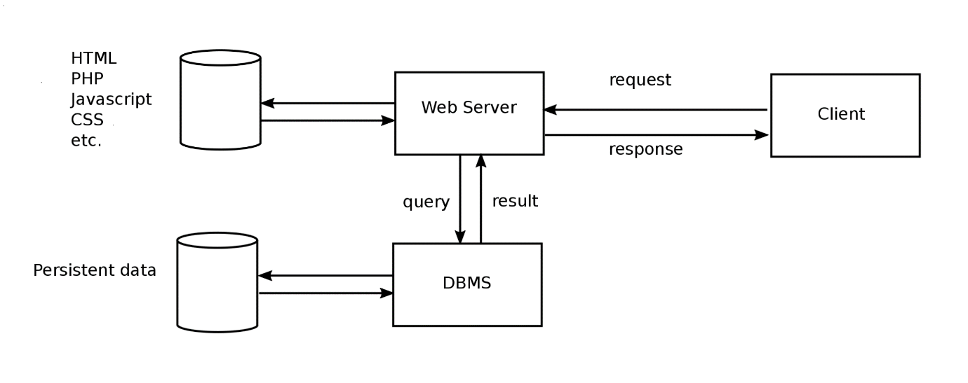

Figure Structure of a dynamic website (Edel Sherratt)

You can refer to your figure from more than one place (Figure 1.)

1. Requirements
2. Spikework
3. Design
4. Implementation
5. Testing
6. Packaging?
7. Critical Evaluation

The critical evaluation consists of a discussion, leading to conclusion. It is an essential part of a master’s degree.

It shows that you can not only carry out a substantial piece of work, but that you can reflect on it, and think critically about how you might have done it better.

Examiners view the critical evaluation as very important.

Critical evaluation should contain

* Strengths and weaknesses of your project
* If you were unable to attain any deliverables, then why
* What are the future plans for your project if you are to continue

You will be presenting this during demonstration but here you need to discuss them in details.

1. Conclusion

A brief summary of all that has gone before, including the key results of the project.

May also include some directions for future work.

# References

|  |  |
| --- | --- |
| [1] | I. Jones, “New kinds of red ink,” *Inky Journal of Pigments,* vol. 336, no. 5, pp. 55-58, March 2010. |
| [2] | M. Copilot, *Prompt: What is green IT, https://www.bing.com/chat,* Accessed: 24 February 2025, 2024. |

Appendix A

Generative AI

1. No AI was used for the project.

Third Party Code and Software Libraries

1. .NET’s ASP.NET libraries have been used for this project. The document template created by the dotnet CLI tool produces a set structure for the Model-View-Controller parts of the project. The CLI tools were also used to generate the Entity Framework Core code in most Controllers. The CLI generated code was then adjusted to make it relevant to this application.

Appendix B- Manual testing table

|  |  |  |  |  |  |  |
| --- | --- | --- | --- | --- | --- | --- |
| Test Ref | Req | Test Content | Input | Output | Pass Criteria | Pass/ Fail |
| T-01 |  | Does the application start | Click on the Turtlebot.exe | The application opens with the default values and layout as shown: | No port is currently displayed in the top right, along with two red boxes. The default code of “turtle.down()  turtle.forward(20)  turtle.right(90)  turtle.up()  turtle.forward(20)” is in the textbox |  |
| T-02 |  | Can the default code be run on the simulation? | Click on run after launching the application | The right-hand side shows the turtle drawing and the box underneath the run button displays the commands in the input screen as they are carried out |  |  |
| T-03 |  | Can the virtual turtle be reset? | Click on the Reset button in the turtle box’s top right corner after state left by T-02 | The turtle returns to it’s default position and the output text disappears | No more lines are visible |  |
| T-04 |  | Does a dialogue appear when trying to clear the program? | After the state left by T-02, click the “Clear Program” button in the top right of the code box. | A confirmation dialogue is shown asking “Are you sure you want to clear the program?” | The user is presented with two buttons on the dialogue, one for Yes and one for No |  |
| T-05 |  | Can clearing the program be done? | After T-04, click Yes | The dialogue box disappears, and the code box is now empty | The turtle is reset, and no drawings can be seen. The output box is also blank |  |
| T-06 |  | Can clearing the program be cancelled? | After T-04, click No | The dialogue box disappears. | No other change occurs |  |
| T-07 |  | Can a pop-up be opened to select a port?- no ports available | After launching the application, click settings and Select port when no usb ports are available | A dropdown is shown with “No ports” and a Refresh ports button | Shows until refresh ports is pressed |  |
| T-08 |  | Can refresh be pressed to see new available ports? | After T-07, insert the usb dongle and click Refresh ports | Select port is now shown on dropdown | Ports are available if click on dropdown |  |
| T-09 |  | Can a pop up be opened to select a port?- ports available | After launching the application, click settings and Select port when usb ports are available | A pop up containing dropdown is shown with “Select port” and a Refresh ports button | Ports are available if click on dropdown |  |
| T-10 |  | Can a port be selected? | After the state of either T-08 or 09, click the dropdown and click on COM3 | The popup disappears, COM3 is displayed in the white box on the topbar | The red box next to the word USB in the topbar turns green |  |
| T-11 |  | Can the application show that the usb connection has been stopped | After T-10, unplug the USB dongle | The green box next to the word USB in the topbar turns red |  |  |
| T-12 |  | Can the turtlebot be connected? | After T-10, press the button on the turtlebot on the right of the display | The box next to the word Turtle turns green from red. | The turtlebot displays the word “Hello” |  |
| T-13 |  | Can the turtle move the pen down? | After T-12, type “turtle.down()” into the code box and press run | The turtlebot moves its pen down and, “turtle.down()” is displayed in the output box. | No visual differences to the virtual turtle. |  |
| T-14 |  | Can the turtle move forward? | After T-13, type “turtle.forward(20)”, then press run | The virtual turtle moves forward, “turtle.forward(20)” is displayed in the output box. | The turtlebot moves forward 20mm. |  |
| T-15 |  | Are spelling errors for the turtle caught? | After T-13, type “turte.forward(20)”, then press run |  |  |  |
| T-16 |  | Are spelling errors for methods caught? | After T-13, type “turtle.foward(20)”, then press run |  |  |  |
| T-17 |  | Are syntax errors caught? | After T-13, type “turtle.forward(20”, then press run |  |  |  |
| T-18 |  | Can the turtle move backwards? | After T-13, type “turtle.forward(-20)”, then press run | The virtual turtle moves backwards, “turtle.forward(-20)” is displayed in the output box. | The turtlebot moves backwards 20mm. |  |
| T-19 |  | Can the turtle move the pen up? | After T-12, type “turtle.down()” into the code box and press run | The turtlebot moves its pen up and, “turtle.up()” is displayed in the output box. | No visual differences to the virtual turtle. |  |
| T-20 |  | Can the turtle move 90° right? |  |  |  |  |
| T-21 |  | Can the turtle move 90° left? |  |  |  |  |
| T-22 |  | Can a variable be used for a forward value? |  |  |  |  |
| T-23 |  | Can a variable be used for a right value? |  |  |  |  |
| T-24 |  | Can a variable be used for a left value? |  |  |  |  |
| T-25 |  | Can for loops be used? |  |  |  |  |
| T-26 |  | Can a for loop be used? |  |  |  |  |
| T-27 |  | Are indent errors caught? |  |  |  |  |
| T-28 |  | Can the turtle be stopped? |  |  |  |  |
| T-29 |  | Can the current code be saved? |  |  |  |  |
| T-30 |  | Can saving the file be cancelled |  |  |  |  |
| T-31 |  | Can code be loaded? |  |  |  |  |
| T-32 |  | Can loading code from a file be cancelled? |  |  |  |  |
| T-33 |  |  |  |  |  |  |
| T-34 |  |  |  |  |  |  |
| T-35 |  |  |  |  |  |  |
| T-36 |  |  |  |  |  |  |
| T-37 |  | Insert number |  |  |  |  |
| T-38 |  | Change font size |  |  |  |  |
| T-39 |  | Select port-None available |  |  |  |  |
| T-40 |  | Select port |  |  |  |  |
| T-41 |  | Connect turtlebot |  |  |  |  |
| T-42 |  | Run code on turtlebot |  |  |  |  |
| T-43 |  | Pen height |  |  |  |  |
| T-44 |  | Pen height up |  |  |  |  |
| T-45 |  | Pen height- down |  |  |  |  |
| T-46 |  | Setup wizard- no port |  |  |  |  |
| T-47 |  | Setup wizard port |  |  |  |  |
| T-48 |  | Setup wizard- backlash |  |  |  |  |
| T-49 |  | Setup wizard- backlash |  |  |  |  |
| T-50 |  | Setup wizard- backlash |  |  |  |  |
| T-51 |  | Setup wizard- diameter |  |  |  |  |
| T-52 |  | Setup wizard- short |  |  |  |  |
| T-53 |  | Setup wizard- long |  |  |  |  |
| T-54 |  | Setup wizard- correct |  |  |  |  |
| T-55 |  | Setup wizard- diameter |  |  |  |  |
| T-56 |  | Setup wizard- short |  |  |  |  |
| T-57 |  | Setup wizard- long |  |  |  |  |
| T-58 |  | Setup wizard- correct |  |  |  |  |
| T-59 |  | About |  |  |  |  |